**Task 9**

1. How to display the last column of each line of file on the terminal using awk?

Syntax : **awk ‘{print $NF}’ <filename>**

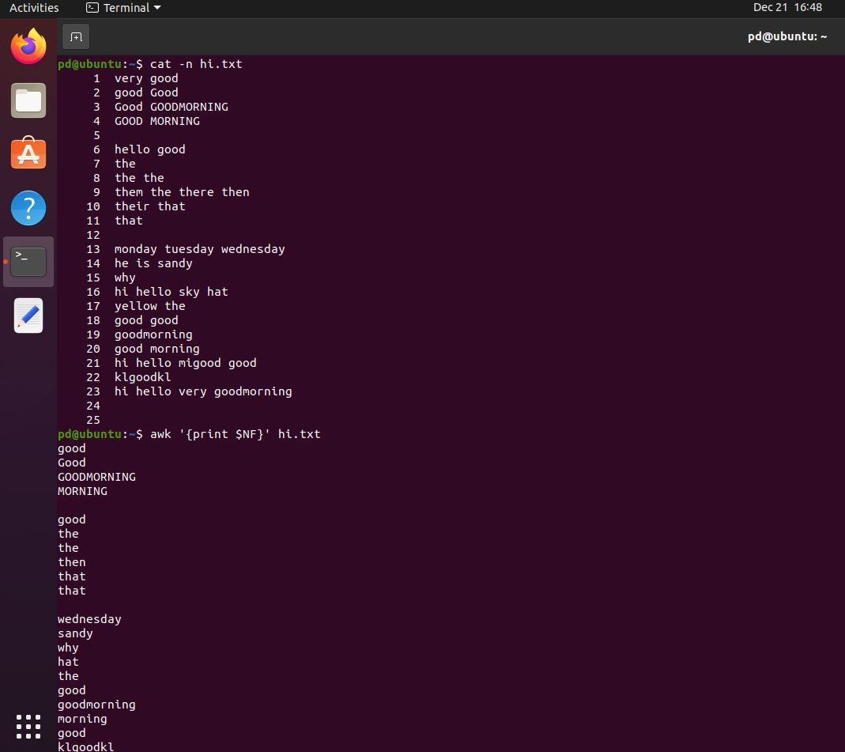

1. What command to display the line number followed by second and fifth column of a file using awk?

Syntax : **awk ‘{print NR $2,$5 }’ <filename>**

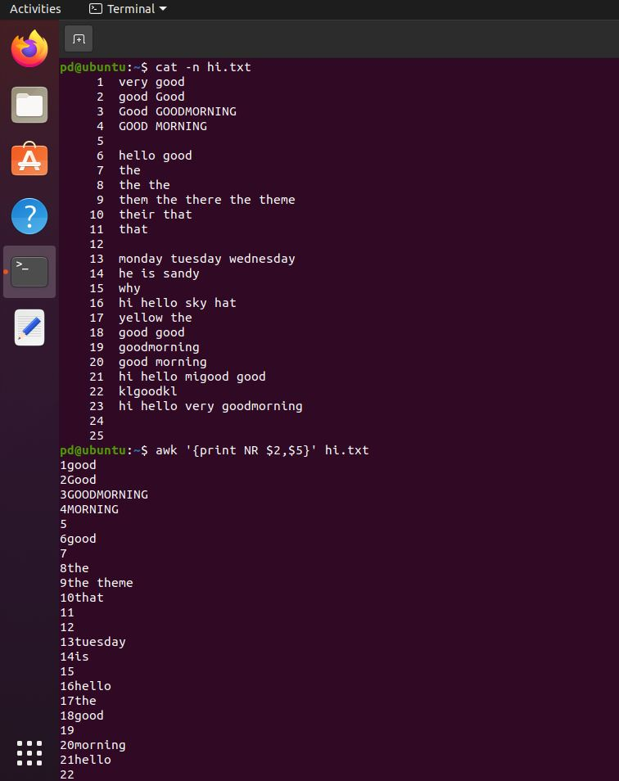

1. How to display the line numbers where the content is not present (empty lines) using awk

Syntax **: awk ‘NF == 0 {print NR}’ <fine name>**

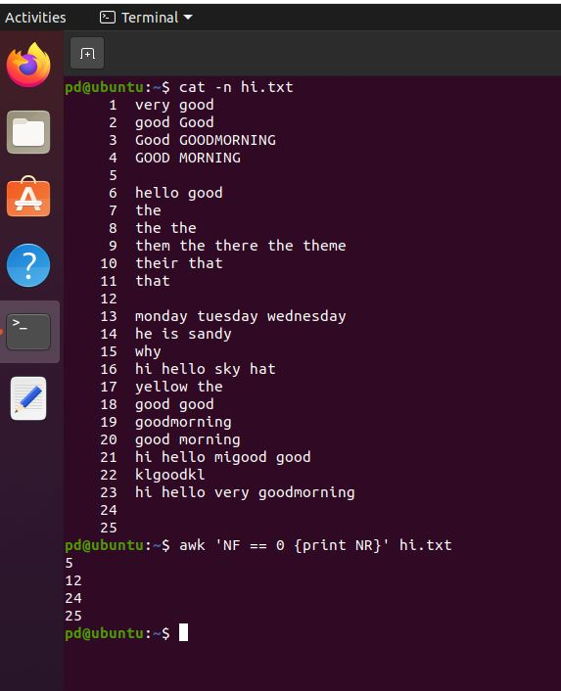

1. What is the difference between hard link and soft link

|  |  |
| --- | --- |
| **Hard Link** | **Soft Link (Symbolic Link)** |
| Additional name for the existing file. | A shortcut to another file. |
| The actual data (inode) of the file. | The file's location (path). |
| Stays valid even if the original file is deleted. | If the original file is moved or deleted, the link will no longer work. |
| If the original file is altered, it is reflected in the link as well. | If the original file is altered, it is reflected in the link as well. |
| Used to create multiple names for the same file. | Used to create shortcuts or references to files. |